Overview
My project is a productivity dashboard that displays daily quotes, background images, the current time, a habit list with streak tracking, a daily checklist, customization options, and local-storage synchronization. Its purpose is to motivate users, help them stay focused, and support consistent productivity by providing deadlines, reminders, and small digital rewards for success. The problem I’m trying to address is the tendency toward laziness, boredom, and regret that comes from misusing time. My motivation for building this project is to improve my own productivity and motivation as I use and refine the program.
Target Audience
The target audience includes students managing homework, habits, and daily tasks; young adults and working professionals who want to build routines and stay organized; remote workers who benefit from a dashboard to start their day; and individuals building new habits such as exercise, scripture study, reading, or personal goals. This project serves these users by motivating them, helping them pursue their goals, and supporting consistent, focused effort.
Major Functions
- Daily quote
- Daily background
- Current time panel
- Habit list
- Habit streak tracker
- Daily checklist
- Dashboard customization
- Local storage sync
These functions will pull motivational quotes from ZenQuotes, fetch images from Unsplash, use WorldTimeAPI to show local time and deadlines, allow users to add or remove habits, track consecutive days completed, mark tasks as done, customize themes and layouts, and save user data between sessions.
Wireframes
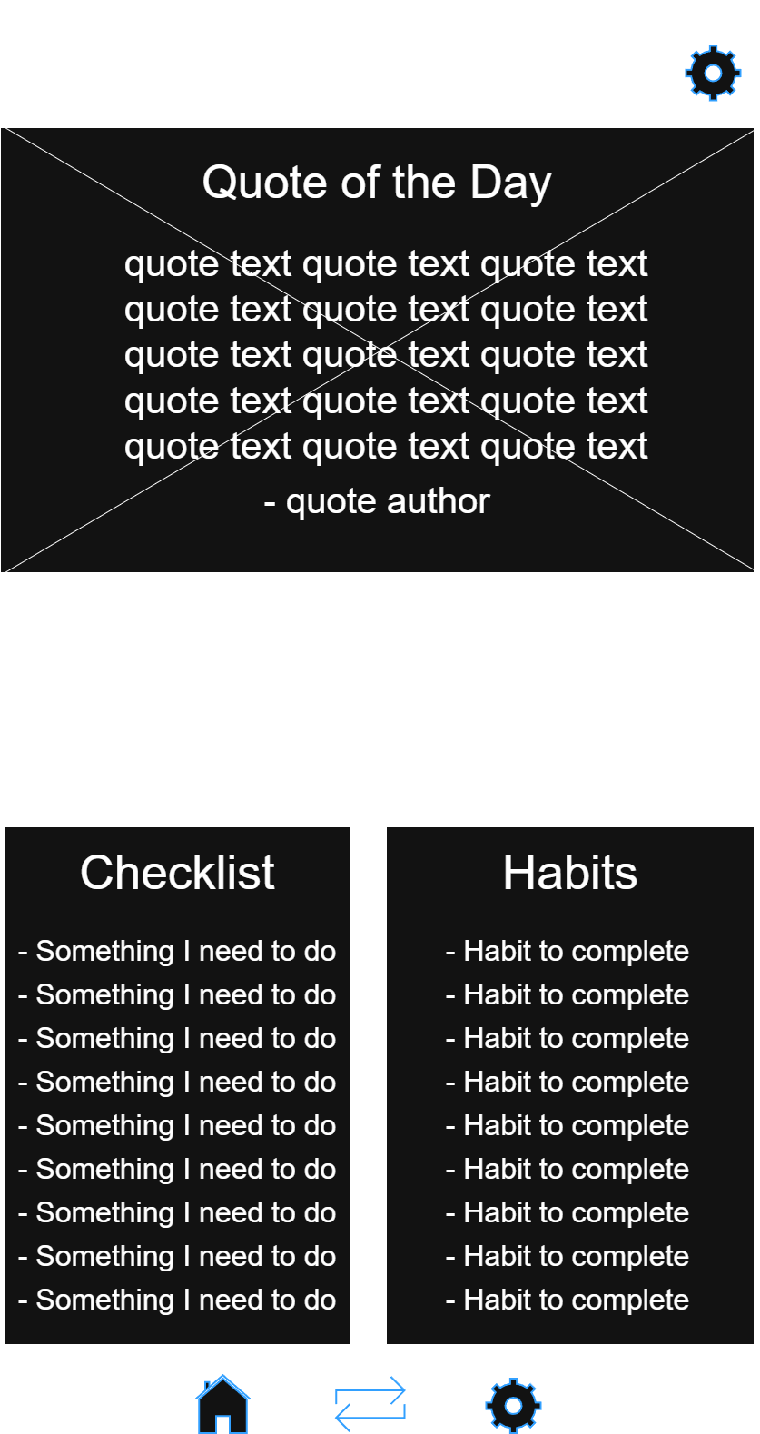
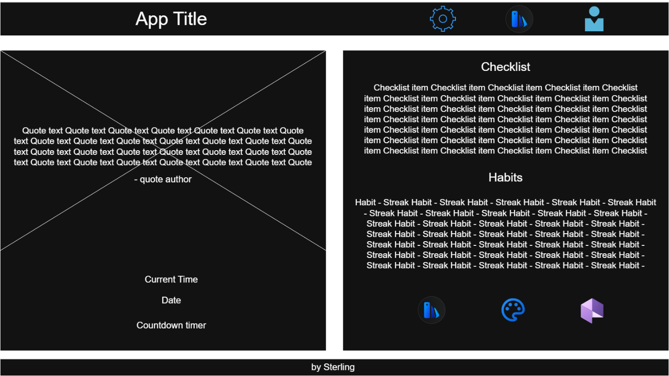
External Data
The external API data sources I will use be ZenQuotes, Unsplash, and WorldTime. The data I will need to store include habit, checklist, user customization settings, api cache, time and deadlines preferences.
Module List
The modules I will need to build are: quotes.mjs, background.mjs, time.mjs, habits.mjs, checklist.mjs, settings.mjs, storage.mjs, ui.mjs, app.mjs. The major components of the application include:
- Quote component
  - Fetches and displays the motivational quote
  - Uses ZenQuotes API
  - Handles caching so the quote stays the same all day
- Background image component
  - Retrieves the daily background image
  - Uses the Unsplash API
  - Applies the image to the UI and stores the URL
- Time and date component
  - Shows the current time and date
  - Uses WorldTimeAPI
  - Displays countdowns/timers
- Habit tracker component
  - Display’s the user’s habit list
  - Tracks daily completion
  - Calculates streaks
  - Saves habit data
- Daily checklist component
  - Show’s the user’s daily tasks
  - Allows checking/unchecking items
  - Store checklist data
- Customization / settings
  - Manages theme (light/dark)
  - Handles color palette choices
  - Stores layout and background preferences
- Storage component
  - localStorage handler
  - Saves and loads all user data
- UI rendering component
  - Dashboard sections
  - Updates DOM elements when data changes
  - Manages layout for mobile and desktop
- Main application controller
  - Initializes the app
  - Coordinates components
  - Sets up event listeners
Graphic Identity
The color scheme will be:
Primary colors
- Primary accent: #4A90E2
- Primary dark: #1F2A44
Secondary colors
- Secondary accent: #50E3C2
- Secondary soft: # F5A623
Neutral colors
- Background light: #F7F9FC
- Background dark: #1A1A1A
- Card/panel background: #FFFFFF
- Text primary: #333333
- Text secondary: #666666
The typography will be:
Heading
- Font: Poppins or Montserrat
- Style: Bold, rounded, modern
- Use: Section titles and dashboard header
Body
- Font: Inter or Roboto
- Style: clean, readable
- Use: quotes, checklist items, habit names, UI labels
The specific element styling details include:
Cards/panels
- Rounded corners
- Soft shadow
- Padding
- Background
Buttons
- Primary button: blue background, white text
- Hover: slightly darker blue
- Rounded corners
- Padding
Checklist
- Checkbox + task text
- Completed tasks get a strikethrough with gray text
Habit tracker
- Checkbox/toggle
- Habit name
- Streak indicator with a “fire” icon and number
- Completed habits get a green checkmark and slight opacity reduction
Daily quote
- Centered text
- Italicized
- Author line is smaller font
- Subtle border options
Background image
- Full-width
- Slight overlay gradient (for readability)
The application icon will be a green checkmark with a bright yellow sun behind it.
Timeline
Week 5
- File structure
- Scaffolding JS
- Connect and test API connections
- Basic dashboard layout
- Displaying quote, background image, time
- LocalStorage module works
- Initial UI
Week 6
- Habit tracker completed
- Daily checklist completed
- Settings, theme toggle, color palette, and background icons complete
Week 7
- UI completed
- Layout finalized
- Error handling
- LocalStorage completed
- Checkup on mobile and desktop views
- Video recorded
- Submission ready
Project planning
Backlog cards on Trello – Tasks
Challenges
I anticipate the biggest challenges in building this application will be coordinating multiple API calls while maintaining layout consistency, managing and storing data in localStorage—especially for settings and customization—and creating a responsive CSS layout that works well on both mobile and desktop views.

